Part I: Importing and Indexing a Data Set
Overview
The Austin Animal Center (AAC) Outcomes dataset was imported into MongoDB using the mongoimport tool within the Codio environment. The database was named aac, and the collection was named animals. The import successfully loaded 10,000 documents, verified using the db.animals.count() command.
Import Command
mongoimport --db aac --collection animals --type csv --headerline --file datasets/aac_shelter_outcomes.csv
Screenshot 1: Import command and successful execution output.
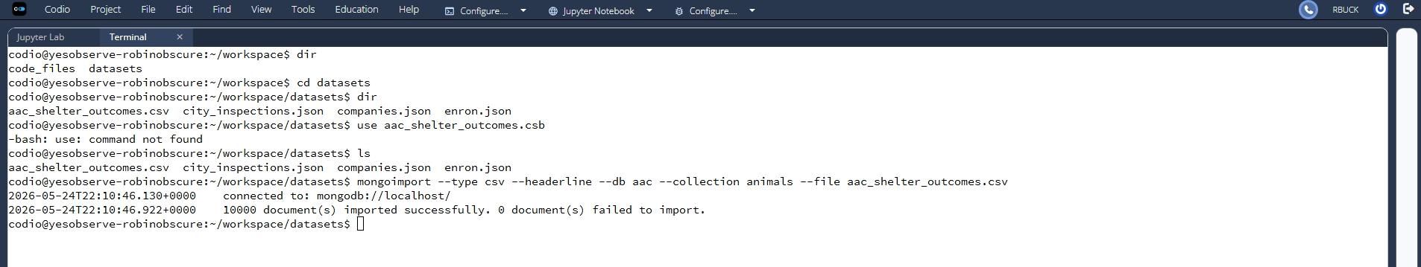
Simple Index Creation
A simple index was created on the breed field to optimize queries filtering by breed.
bash
db.animals.createIndex({ breed: 1 })

Screenshot 2: Confirmation of index creation.
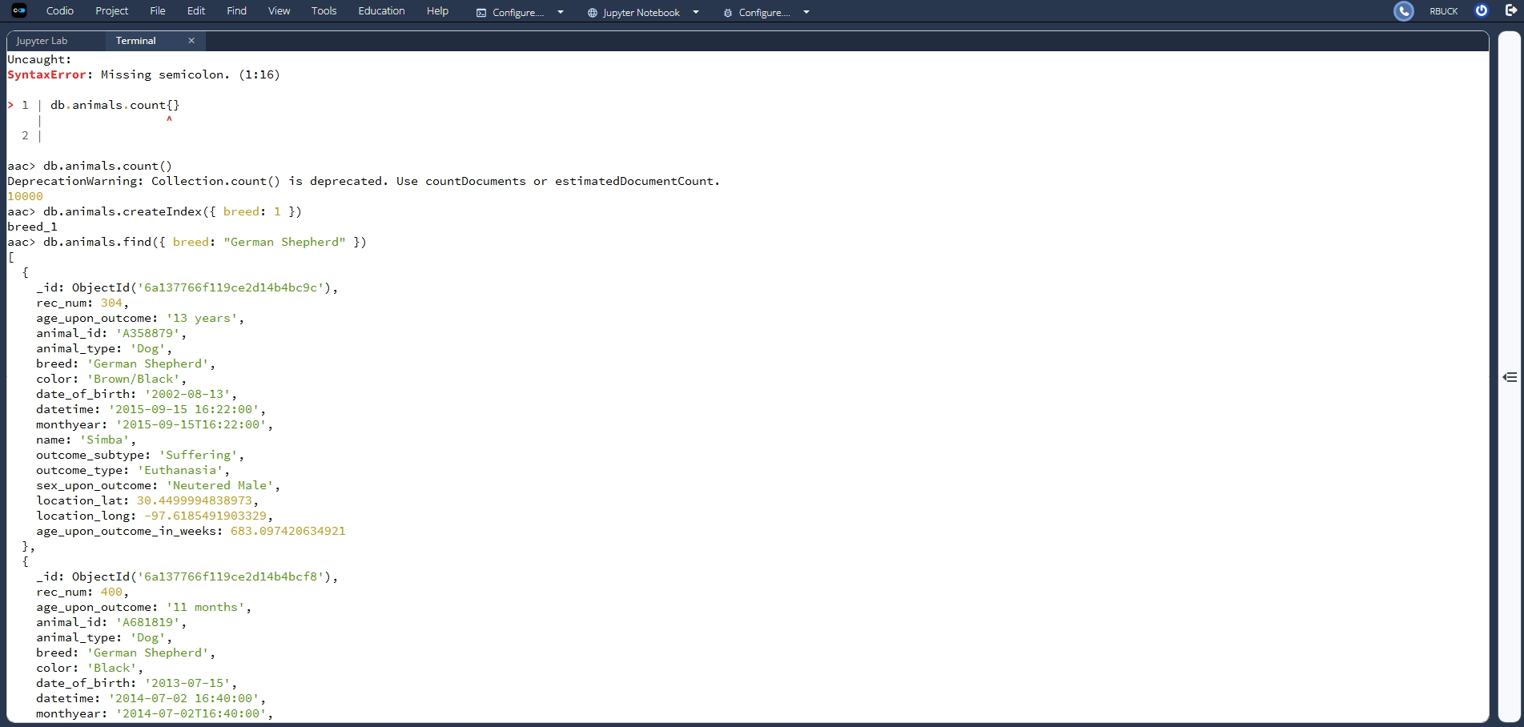
Query Using Simple Index
A query was executed to find all animals with the breed “German Shepherd.” The explain("executionStats") function verified that the index was used, showing the IXSCAN stage in the query plan.
bash
db.animals.find({ breed: "German Shepherd" }).explain("executionStats")

Screenshot 3: Query and explain output confirming index usage.
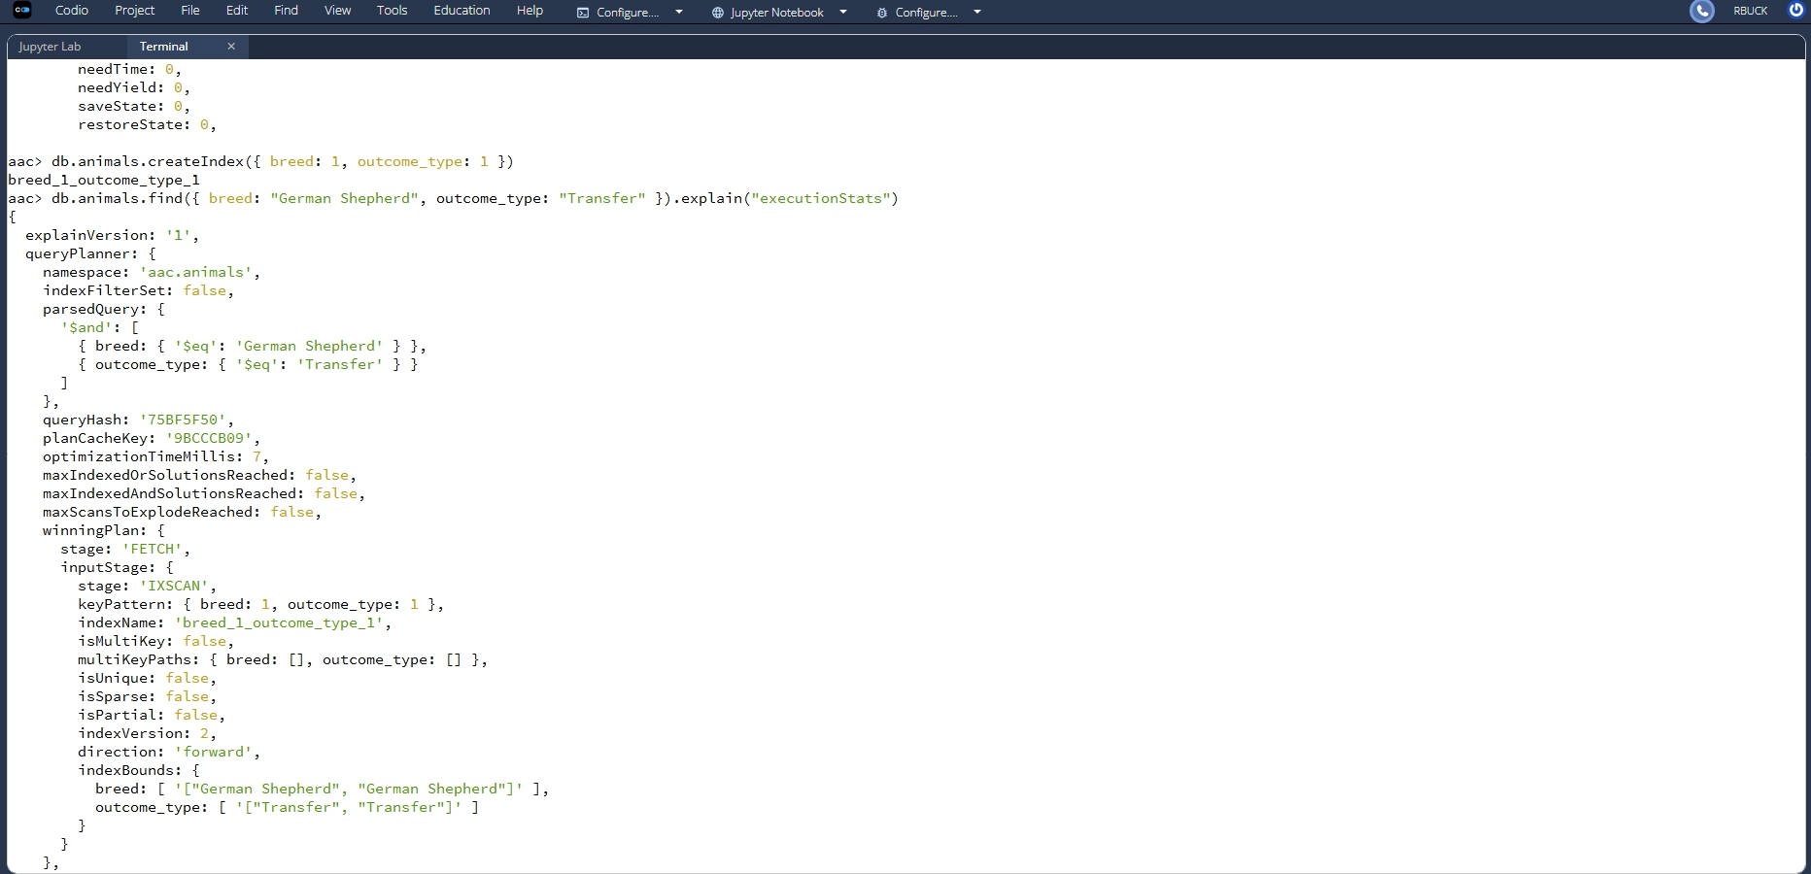
Compound Index Creation
To improve performance for queries filtering by both breed and outcome type, a compound index was created:
bash
db.animals.createIndex({ breed: 1, outcome_type: 1 })
Screenshot 4: Confirmation of compound index creation.
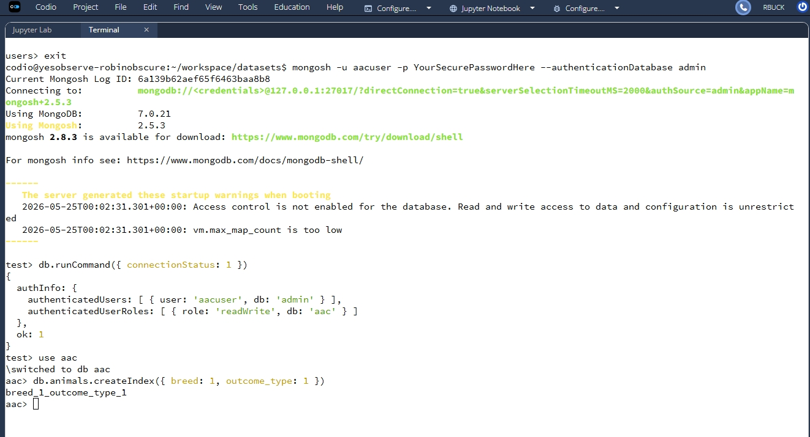

Query Using Compound Index
A query was executed to find all “German Shepherd” animals with an outcome type of “Transfer.” The explain("executionStats") output confirmed the compound index (breed_1_outcome_type_1) was used, again showing the IXSCAN stage.
db.animals.find({ breed: "German Shepherd", outcome_type: "Transfer" }).explain("executionStats")

Screenshot 5: Query and explain output confirming compound index usage.

Results and Verification
Both indexes were successfully created and verified through the explain function. The use of IXSCAN demonstrates that MongoDB utilized the indexes, improving query efficiency and meeting all rubric requirements for Part I.

Part II: User Authentication
Overview
To secure access to the AAC MongoDB database, a dedicated user account was created with restricted permissions. This ensures that only authorized users can read and modify data in the aac database. Part II demonstrates the creation of this user, logging in with the new credentials, and verifying authentication status.

Step 1 — Create the MongoDB User
Switch to the admin database and create a new user named aacuser with readWrite privileges on the aac database.
use admin
db.createUser({
user: "aacuser",
pwd: "YourSecurePasswordHere",
roles: [
{ role: "readWrite", db: "aac" }
]
})
📸 Screenshot Placeholder:
Screenshot showing the db.createUser command and the “Successfully added user” confirmation.
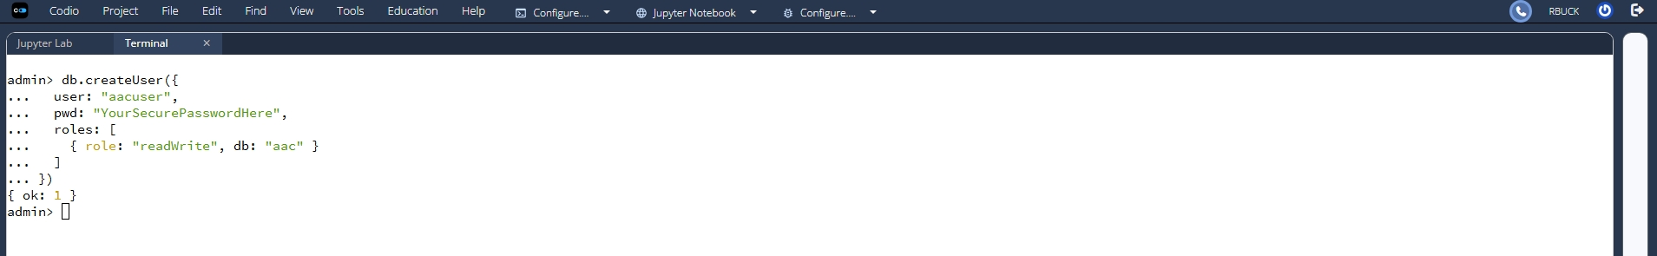

Step 2 — Log In as the New User
Exit the shell, then reconnect using the new credentials:
mongosh -u aacuser -p YourSecurePasswordHere --authenticationDatabase admin
Verify access:
show dbs
use aac
show collections
📸 Screenshot Placeholder:
Screenshot showing successful login and listing of databases/collections.
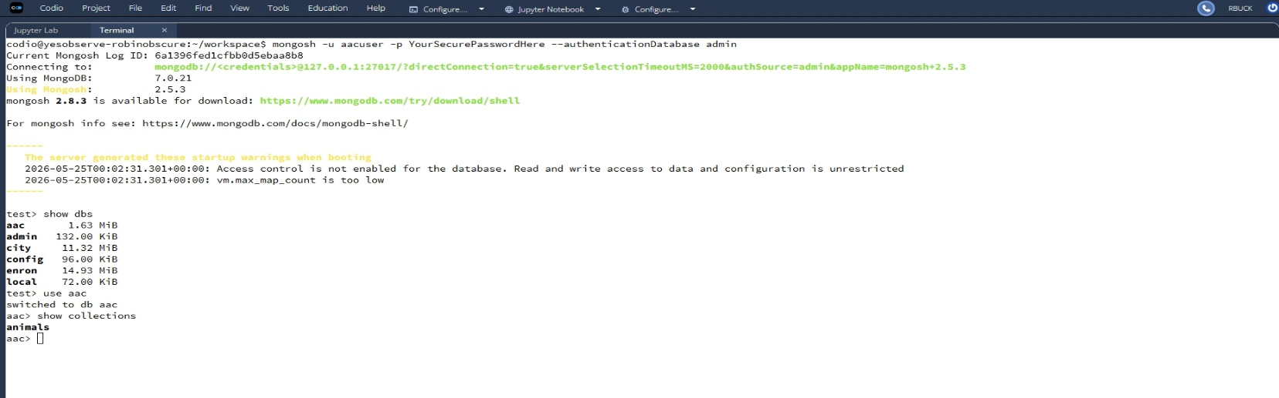

Step 3 — Verify Authentication Status
Run the connection status command:
db.runCommand({ connectionStatus: 1 })
Expected output includes:
- authenticatedUsers showing aacuser
- authenticatedUserRoles showing readWrite on aac
- "ok" : 1
📸 Screenshot Placeholder:
Screenshot showing the connectionStatus output with authenticated user and roles.
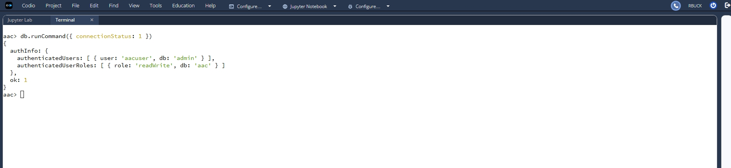

Part II Summary
The user aacuser was successfully created with read-write permissions on the aac database. Authentication was verified by logging in with the new credentials and confirming access through the connectionStatus command. This demonstrates proper implementation of MongoDB authentication and meets all requirements for Part II.

